# Desert Albedo Update

In deep time simulations, we typically use an “average” soil everywhere. This is probably reasonable for areas that are vegetated but not appropriate for most desert regions. When there are desert regions, the hydrological properties of soils are not very important, but the high albedo effect of deserts is dominant. Indeed, in non-desert regions the soil is covered by vegetation, and it could therefore be argued that it would have been better to specify a high desert-like surface albedo over the whole planet since the albedo would be correct over the desert and would have little impact elsewhere. In practice, by making the albedo an average medium loam, we are making the surface darker (and hence the planet warmer) than it should be.

Since there is little opportunity for producing soil maps for deep-time, it seemed a good idea to produce an update that linked albedo to some aspect of the rest of the model physics. We could simply make albedo related to bare soil fraction, but one of the reasons that the albedo of deserts is high is because it has low organic carbon content. Hence it seemed more appropriate to link soil albedo to soil carbon. It makes the update more physically based. This was the basis of the dynamic albedo model used in the MPI model (Vamborg et al 2011). They used a relatively sophisticated parameterisation which would take some effort to re-implement for HadCM3 and included a geographically varying bed rock function which we would not have for deep time paleo. Instead a simpler scheme was developed.

## Starting Point

Figure 1 shows high resolution HadGEM3 data. There is some link between soil carbon (or bare soil fraction), and snow free soil albedo but it is not especially clear cut globally.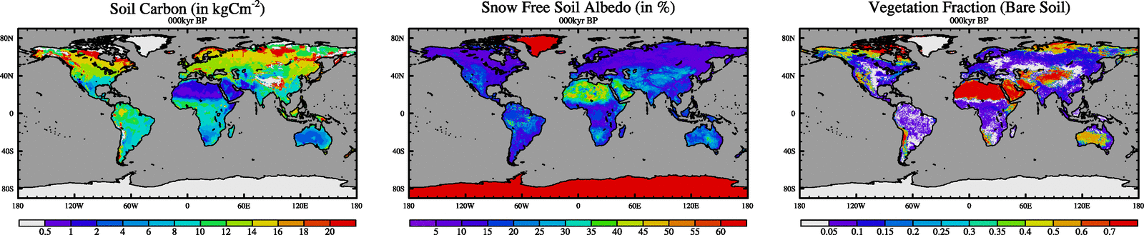

If we zoom up on the Sahara, the same conclusion applies. There is considerable albedo variability within the Sahara which is not represented by the soil carbon. This is largely understandable as the surface albedo will depend on the bed-rock type etc. as well as the carbon.

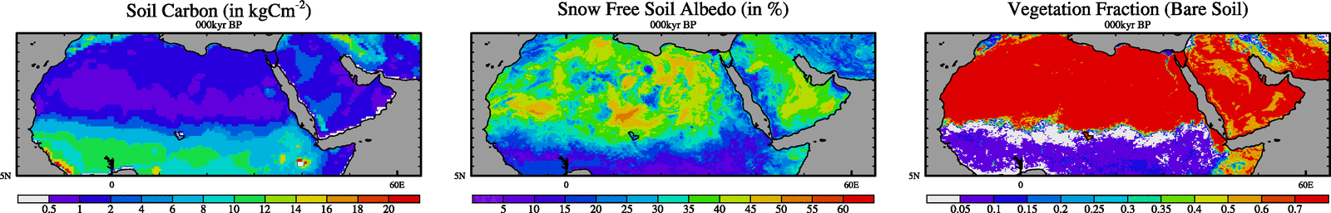

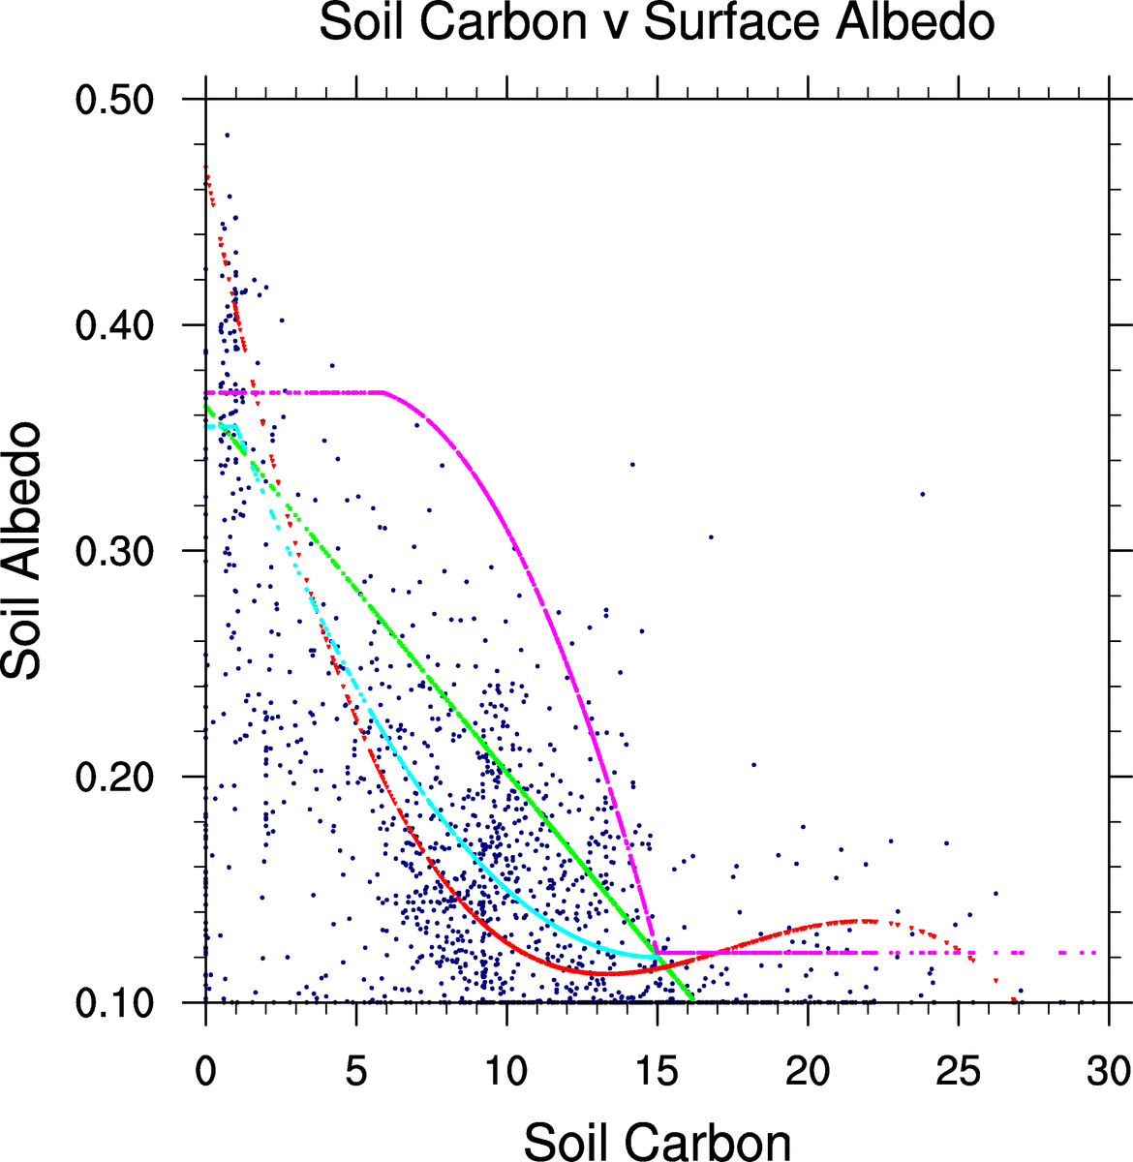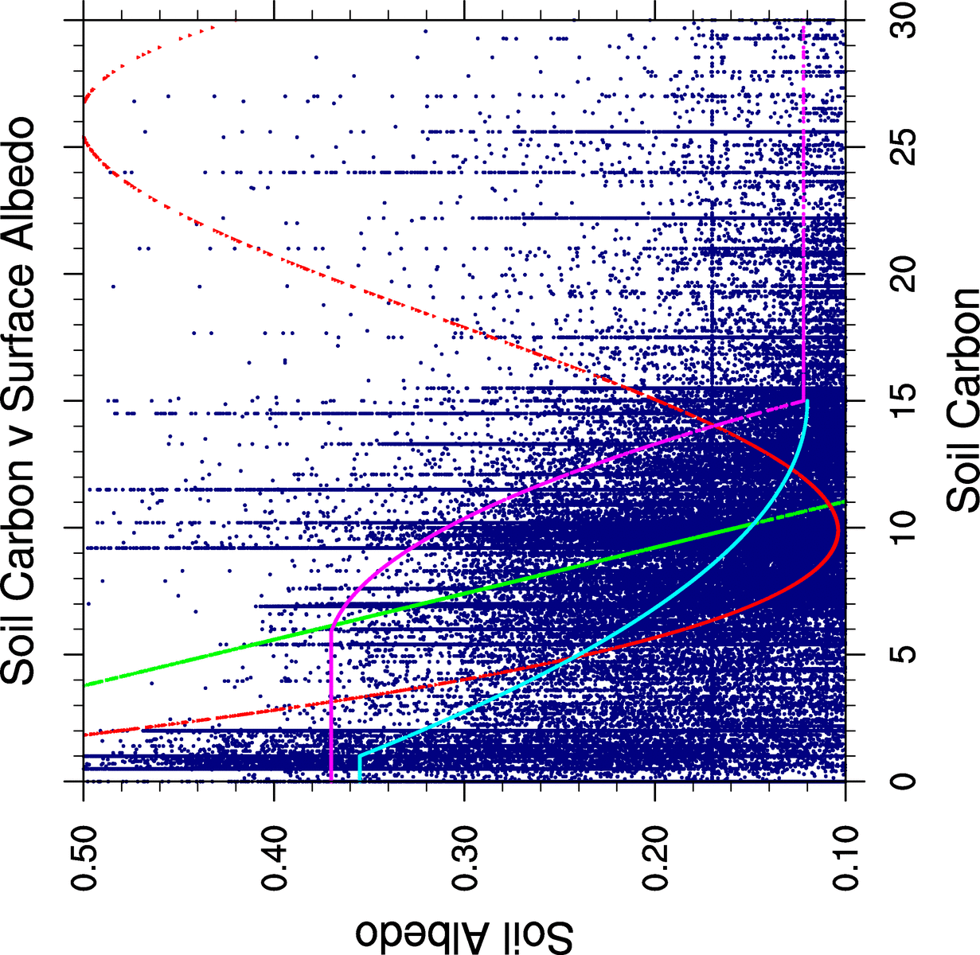In order to try and estimate a simple relationship, I performed a simple scatter plot. Firstly, I took the high-resolution data and plotted soil carbon v surface snow free soil albedo. This produced a plot which had a huge amount of scatter and no relationship. In general, low carbon does result in high albedo but with considerable variation. Also plotted is a simple linear regression (green colour), a cubic regression (red colour), and two proposed simple relationships (cyan = desert_albedo_02 and pink=desert_albedo_03). The scatter plot also shows lots of “lines” of dots. It is not entirely clear why, but I suspect it is because the real resolution of the soil carbon data seems to be lower than the albedo data (this is apparent if you look closely at the Sahara plots) so you can often end up with the same value of soil carbon but varying albedo.

Just in case the high resolution was kind-of “hiding” a bigger pattern, I also tried the same thing but re-gridding the data to HadCM3 scales. This does help quite a lot and does show a clearer link between albedo and soil carbon but there remains a huge amount of scatter.

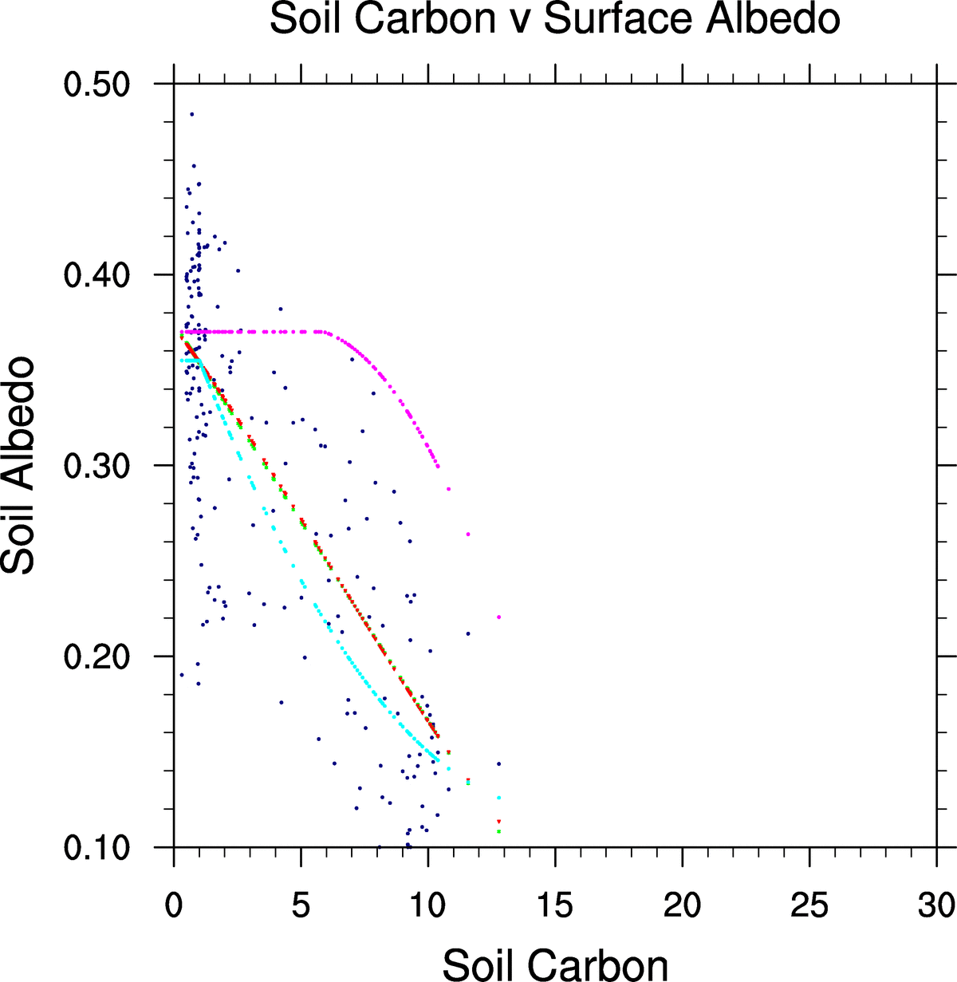Finally, I repeated the plots but focussed over the Sahara region (5 to 35N, 15W to 60E). Disappointingly, it did not have a big impact on the results. There remained a lot of scatter.

From this analysis, I invented two somewhat arbitrary functions of albedo v soil carbon. These are shown by the cyan and pink lines in all the scatter plots. My first choice was the cyan curve. I felt it was similar to the best fit linear regression but was capped near zero. I also used the linear fit based on the high resolution Sahara only regression.

I then coded these up for the observed soil carbon maps. The figure below repeats the previous plot (fig 1), but adds the albedo calculated using three different methods. The left bottom is the cyan curve (desert_albedo_02 mod set), the middle bottom plot is the pink curve (desert_albedo_03 modset) and the right bottom plot is the linear relationship (but capped at a minimum albedo of 0.122). The cyan and linear relationships work pretty well. The pink method is clearly too extreme. There is not much to choose between the cyan and linear relationships. Both give higher albedos in the Sahara, and also in other deserts such as Australia, SW America and coast of S. America. All of which fits the data well. Both also give incorrect high albedo in Siberia. This is because the cold temperatures result in little growth and hence low soil carbon, but the underlying soil must still be dark. In practice, it is likely not going to be very important because such areas are likely to be covered with some vegetation/snow and hence the soil albedo will not be too important.

## Conclusion

I will use the cyan relationship,

albedo=0.27*((carbon-15.0)/15.0)2 + 0.122

albedo = 0.122 if carbon > 15 or if albedo <0.122

albedo=0.355 if albedo>0.355

This is implemented in desert_albedo_02. The mod set only works with MOSES2.1, and includes extra details that could allow future implementations to be latitude dependent. However, currently this is not used.

NOTE: In writing this brief description I realised the original code used a minimum albedo of 0.12. This value had been superseded to 0.122 by my recalculation of soil parameters based on the bugs. See the technical note. I have changed the update to reflect this and created desert_albedo_02_original for the 0.12 value code. This is bad practice (modsets should never be changed) but I decided the change was so small and the update has not yet been used by many people.

High resolution: Bottom left = soil carbon1 (cyan relationship, desert_albedo02 modset), bottom middle=soil carbon2 (pink relationship, desert_albedo03 modset), and bottom right linear.

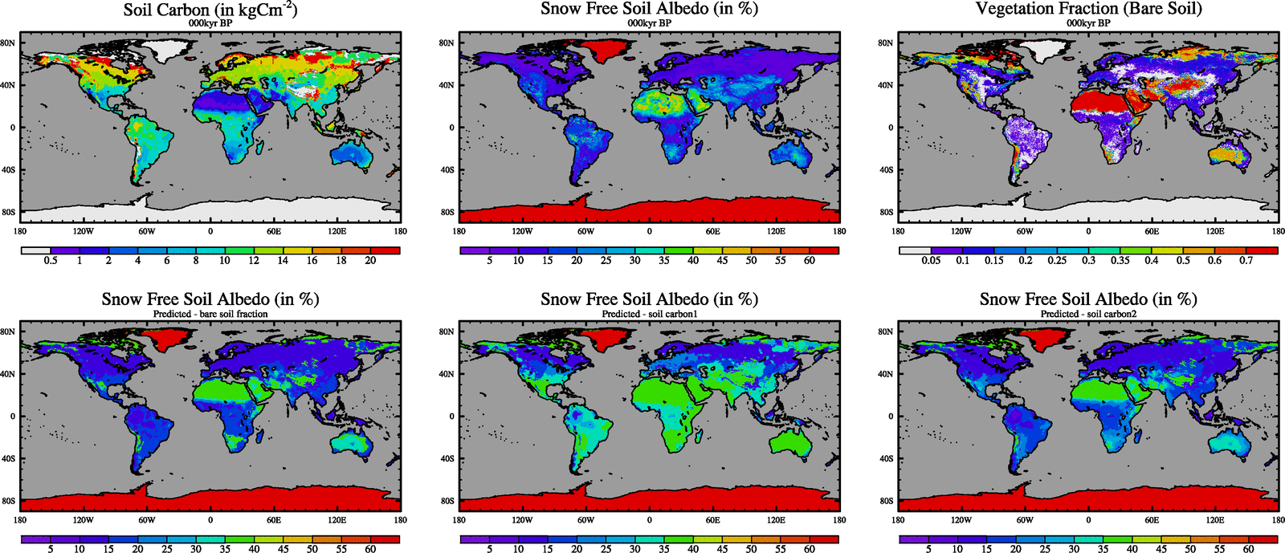

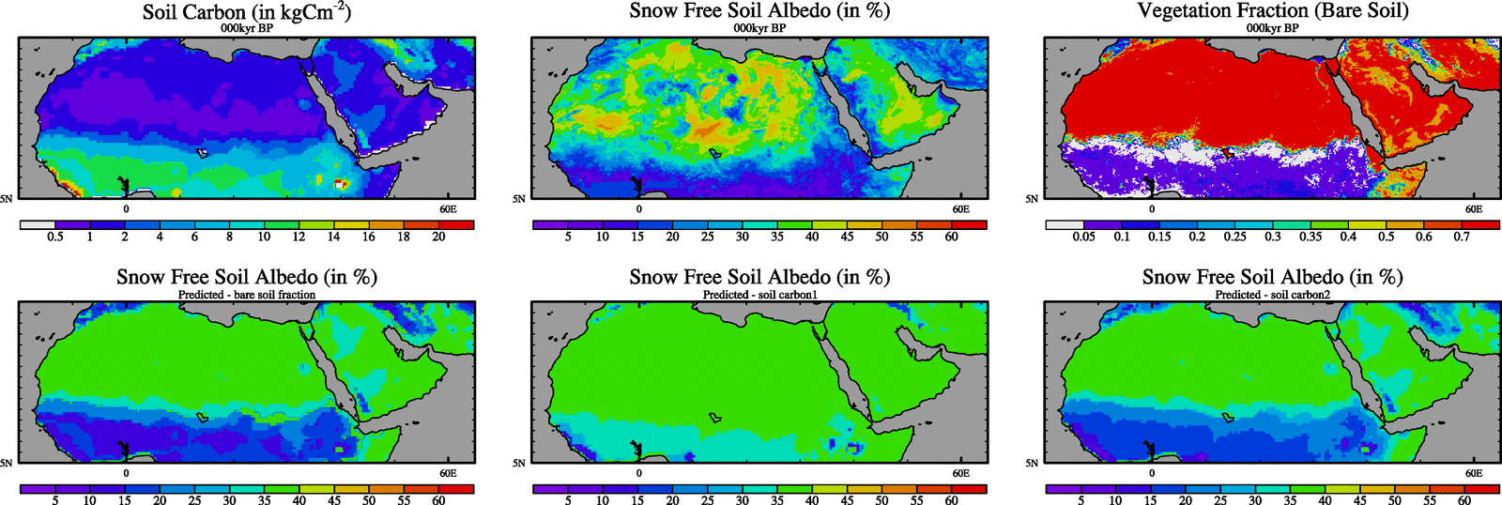As above but zoomed on Sahara

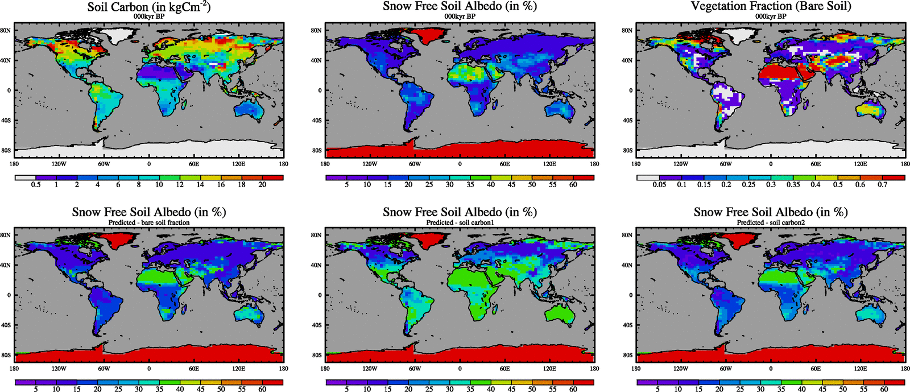As above but low resolution

As above but low resolution, zoomed on Sahara.

