# Checkerboard Patterns in the UM (Part 2)

Initially, I believed that the main source of checker board type patterns originated in the ocean streamfunction. This was because it was a known problem. However, having cured this issue (see part 1), I still saw a lot of two grid waves in the atmosphere. What was the cause?

## Example of the Problem

First of all, in order to better understand and diagnose this problem, I developed a diagnostic which was effective at really showing the problem. An example of this diagnostic is below (figure 1). It is a Danian GETECH paleogeog. Although initially the problem was thought to be the ocean, it can be seen that the noise in the ocean stream function (Fig.1 – top-left) was not especially large. However, noise could be clearly seen in the precipitation (Fig 1 – top-right) beyond the areas impacted by the streamfunction. Less obvious was the sea level pressure (Fig 1 – bottom-left). At first sight, there is little to no checker-board pattern in the mean sea level pressure. However, a more careful inspection shows that the contour lines do have some two grid noise. The issue is that the relatively large gradients in these fields (even more extreme for surface pressure itself) “hide” the noise. To show this, I smoothed the mean sea level pressure using a simple 9-point filter. I then subtracted the smoothed value from the original (Fig.1 – bottom-right). This highlights any small scale features, either from sharp gradients in the data (e.g. at the pole or around orography) or from numerical noise. As can be seem very clearly, there is a lot of noise in this field and it spreads across the whole ocean and land.

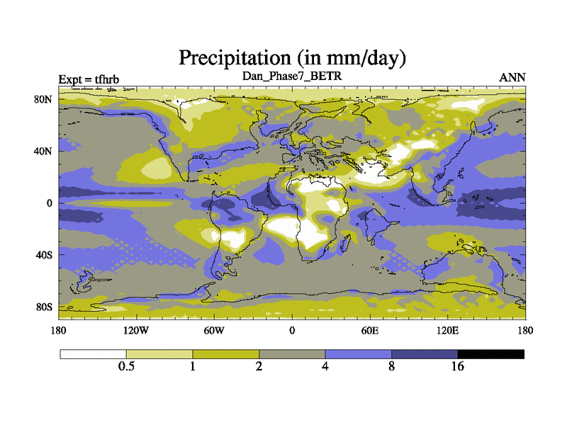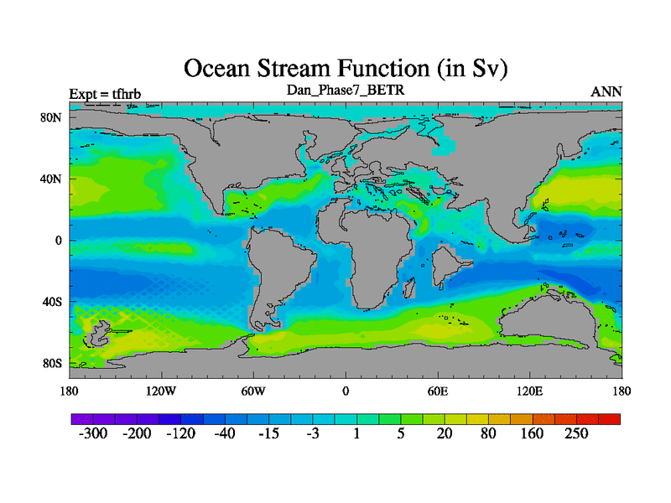

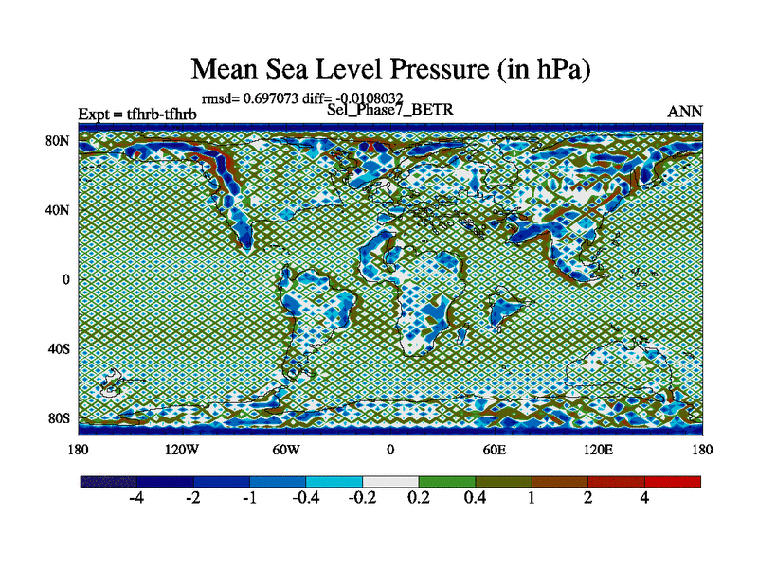

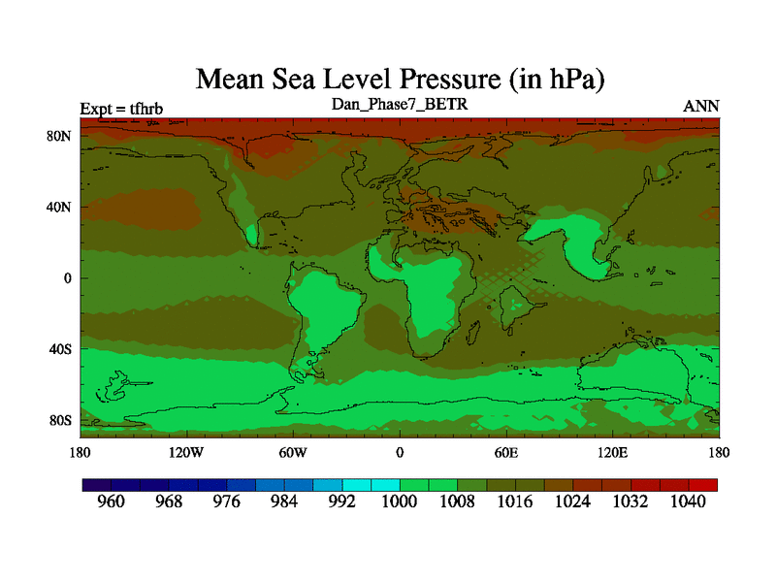

Figure 1. Ocean stream function, precipitation, mslp and the difference between the smoothed mslp and the original.

## Present Day Simulations

My next question was whether I was over-diagnosing the paleo-model outputs (note the contour interval in Fig.1 - bottom-left is small) and whether this was present in all simulations. I therefore checked with a modern simulation, shown in figure 2.

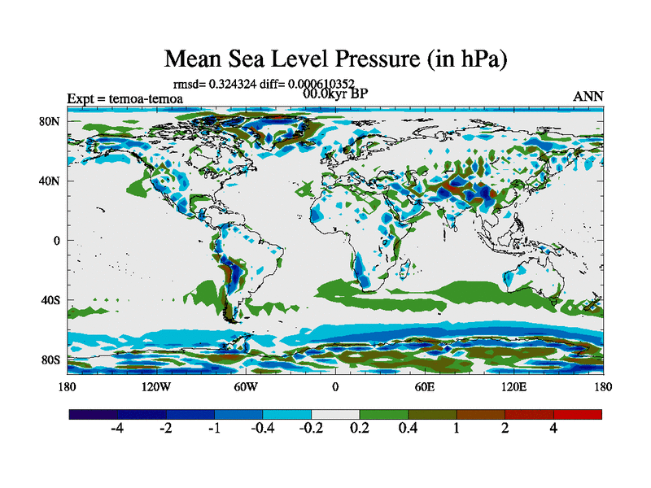

Figure 2. Difference between smoothed and original mslp for a standard pre-industrial simulation

There is almost no equivalent noise. Over land there are some small scale features but I am assuming that they are probably the results of gradients linked to orography and potentially some real atmospheric waves triggered by the mountains. Over the ocean, particularly the southern ocean, there are some hints that there could be some noise but it is so much smaller than the Danian example.

## The plot thickens.

So the problem is real. Next I decided to focus on some of the Maastrichtian simulations performed for the BBC project. Using the “noise” diagnostic, the following shows these for 8 different paleogeogs (Figure 3). There is an interesting diversity of results. Some simulations (top left – a Markwick paleogeog) appear to have no noise. Others have huge amount of noise. The two largest noise simulations are both Robertsons paleogeogs, but tfece is also from Robertsons which has relatively little noise so it appears that it is just chance that two belong to Robos.

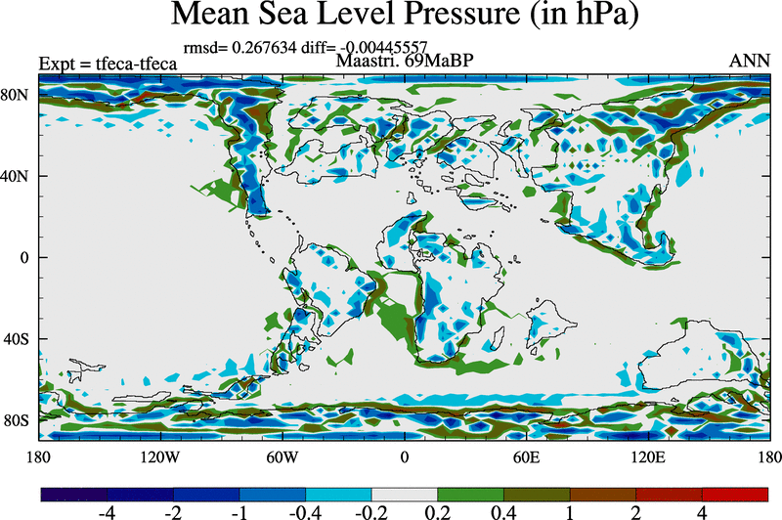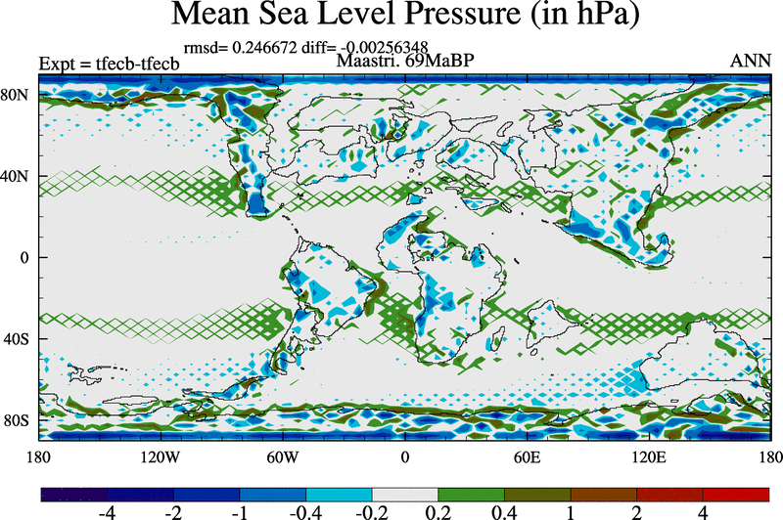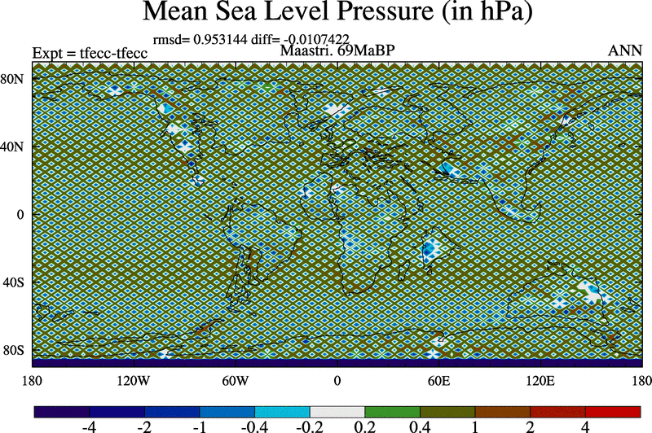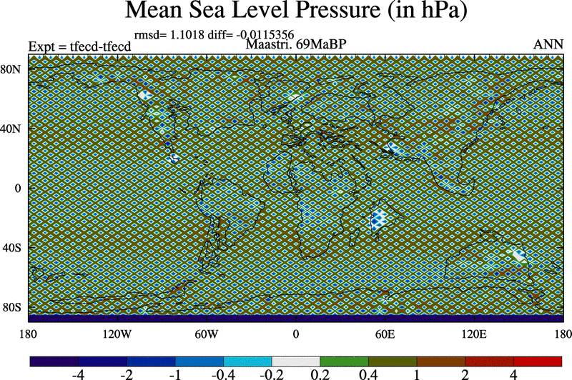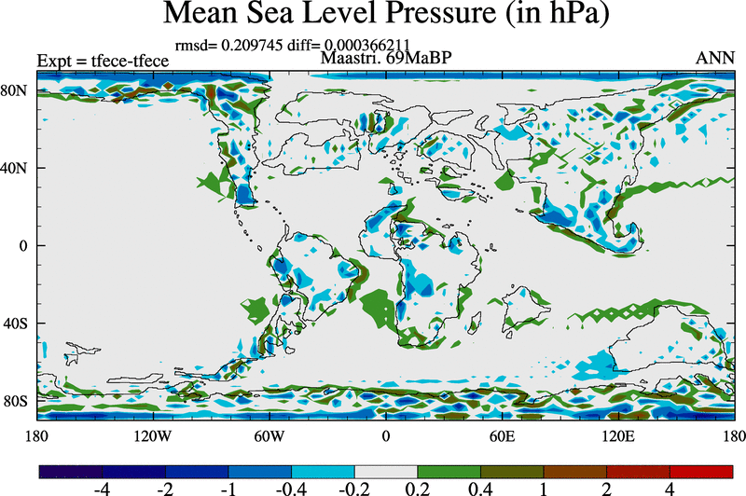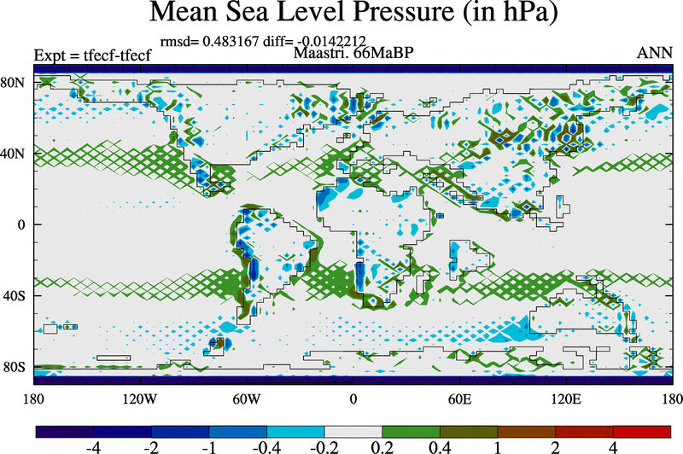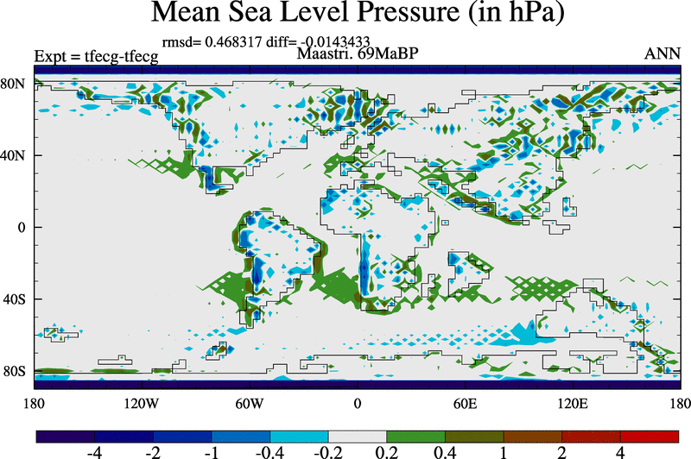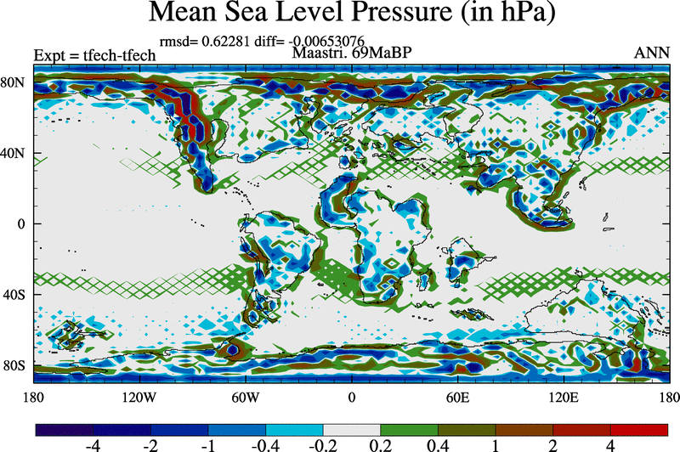

Figure 3. Maastrichtian simulations using a variety of paleogeogs.

These simulations did not have the ocean stream function smoother but none of the models showed significant amplitude noise in the ocean stream function. There is a little but nothing excessive. In addition, the extent of “noise” was consistent across different model setups (e.g. new physics). Changes in the ocean diffusion (which exist in the new physics model) did not impact on the noise. This hints towards an atmospheric source, though it could still be some strange impact of the ocean streamfunction.

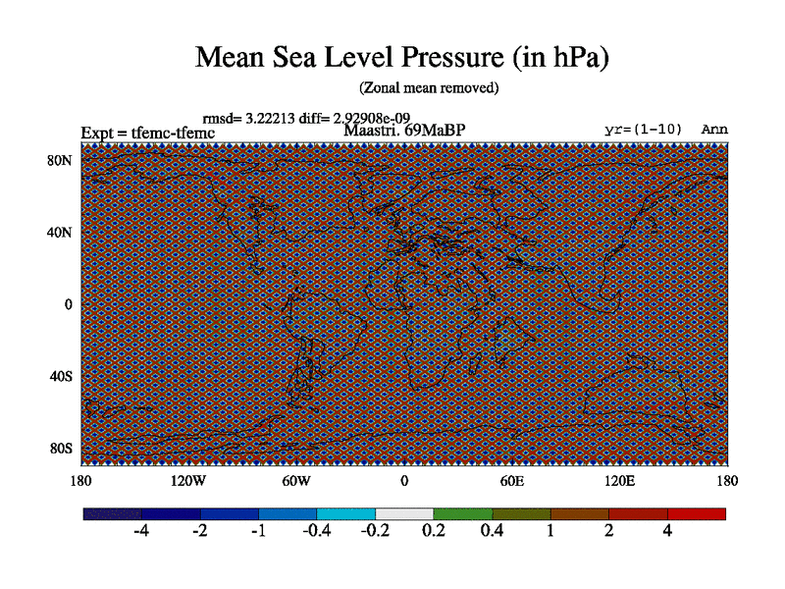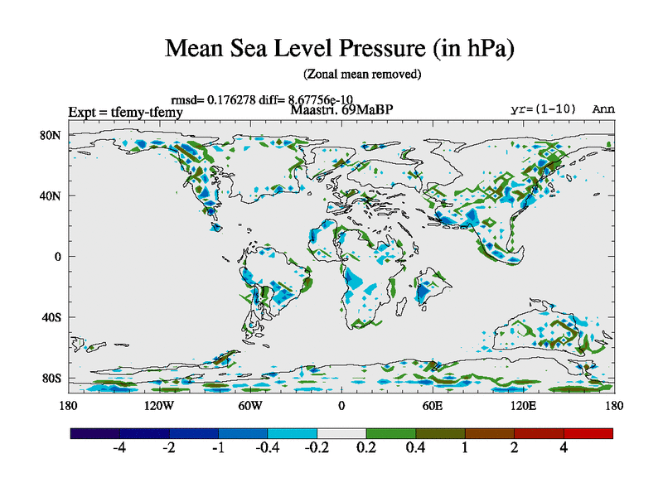I then zoomed in on one of the major “noise” runs, tfecc. The first thing I did was to smooth the dump file so removed all of the noise, and then ran the model. I also included a strong haney forcing towards a smoothed version of the predicted SST. The result was very encouraging. There was barely any noise in the precipitation field or the mean sea level pressure.

Figure 4. Original simulation (left) and revised simulation with smoothed fields in dump file and smoothed SST Haney forcing.

However, further analysis showed that the two grid wave was gradually growing back. A very crude measure of the amount of two grid wave is the root mean square difference (rmsd) between the smoothed and original field. It is crude because the smoothing also impacts sharp gradients but I assume that the component related to sharp gradients is constant. Thus growth in the metric shows growth of the two grid wave.

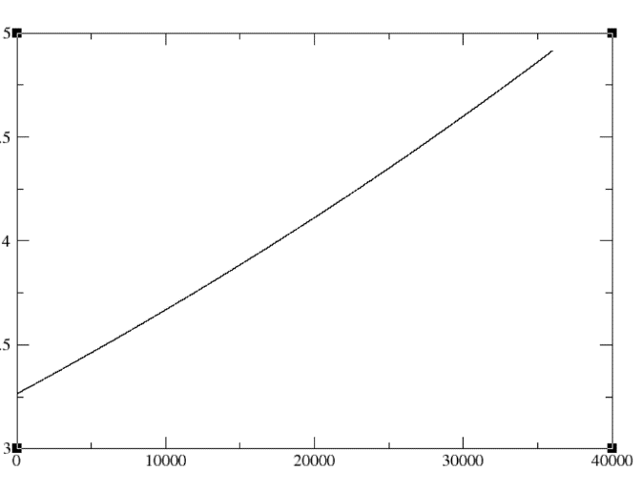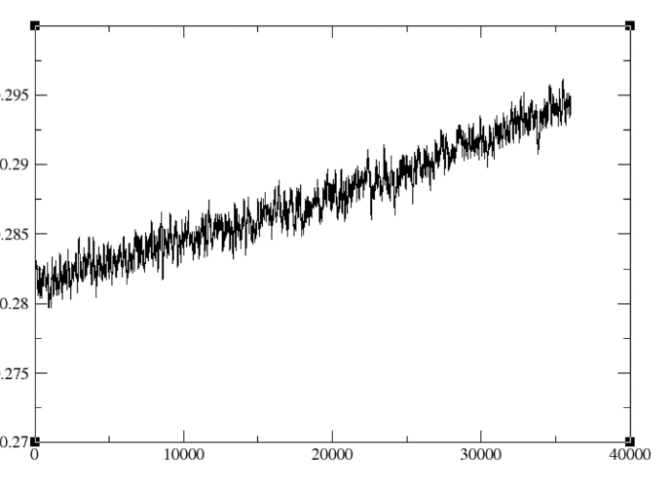

Figure 5. Time series (as a function of months into the run) of the root mean square difference between the smoothed and unsmoothed mean sea level pressure for (a) the original Maas. simulation, and (b) the simulation initialised from a smooth dump and with smoothed SST.

Figure 5 clearly shows that although the magnitude of the two-grid wave is very much smaller in the revised simulation, but it is still beginning to grow. A further extension of this run for another 1000 years confirmed it was continuing to get bigger and bigger. In the original run (fig5a) there is a noticeable curvature to the noise. I hypothesis that this is because the amplitude of the noise has got so large that there is a positive feedback between the pressure, circulation, and SST. In this simulation, the SST pattern definitely has noise and my suggestion is that this then starts to positively feedback onto the mslp.

## Long Transient Runs

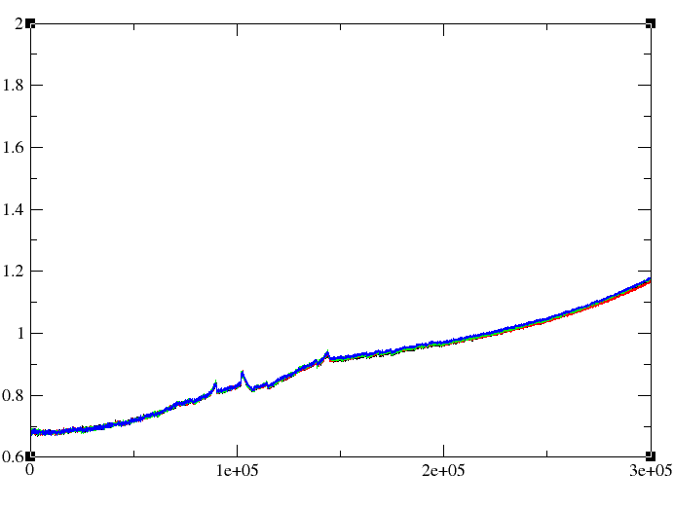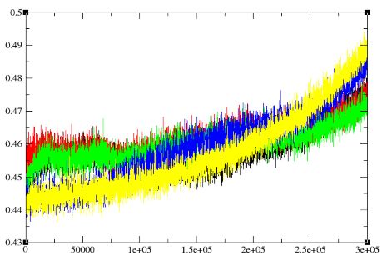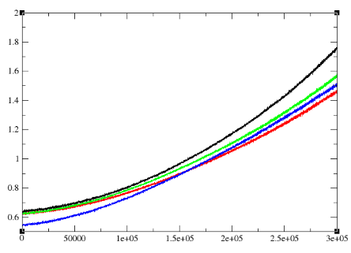As part of the work on the transient deglaciation, we now have some ultralong simulations, totalling 25,000 years (23kaBP to 2kaAP). Some of these have the Peltier ice sheet evolving through time but others simply have orbit or GHGs varying. I also have a simulation where nothing is changing (a 25,000 year control). So I took a look at these simulations in figure 6.

Figure 6. Time series (as a function of months into the run) of the transient deglaciation simulations. Note that the y-axis is different The left hand plot shows a group of simulations where the only changes are GHGs or orbit, or no change. In particular, the yellow curve is basically identical to our normal control simulation. The middle plot shows a group of simulations where the land/sea mask, ice sheet and elevations are different (12kyr, 16kyr, 19kyr 21kyr) but are held constant throughout the simulation. The right hand plot shows four full deglaciation simulations where land/sea mask, ice sheet and elevations are changed every 1000 or 500 years. The differences between these four deglaciation simulations is entirely linked to freshwater assumptions.

The results suggest that all models have noise growing, but some boundary conditions are worse than others.

## Two Problems?

The above analysis leaves me wondering if there are two related parts to the story.

1. Even the standard model has some growth suggesting that it is intrinsic to the model and is not being removed by other processes such as diffusion. Therefore maybe we need to add in a diffusive type process to prevent the growth of noise.
2. In addition, something we are doing to the boundary conditions of the model (when we change land/sea mask, bathymetry or orography) leads to more rapid growth in the noise

## Simplified Test-bed

One of the simulations that had relatively bad noise was the pre-industrial (0.0Ma) Scotese runs (the latest being teyfa). Teyfa is the current end point in a sequence of runs which both extended the run length and introduced new physics to the model (the CCN changes but also updates such as desert etc). Examination of the sequence of simulations (figure 7) showed that the noise has gradually been growing throughout the run. Examination of the full mslp maps shows some signs of the noise but it is not dramatic. However, if we remove the smoothed field it becomes bigger and clearer (figure 8).

## 

Figure 7 shows the Scotese 0.0Ma simulation with each coloured line representing a 1000-3000 year segment of the simulation where the initial condition of the next segment is the end of the previous segment. It is clear that there has been noise increasing throughout the run. The slope looks as if it is slightly steeper at the end of the run but this may also be related to the curvature of the diagnostic, as seen in figure 6. Interestingly, the new model physics was introduced at the yellow line which does look as if the slope increases.

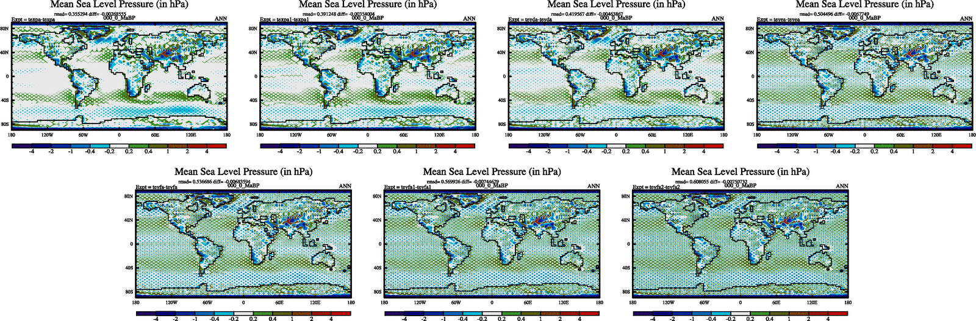

Figure 8. Evolution of two grid wave within the sequence of Scotese 0.0Ma model simulations.

To both understand the origin of the noise and to develop a fast test bed, I setup an atmosphere only version of teyfa. The SST/seaice were extracted from teyfa (corresponding to the bottom left simulation in figure 8 above, and the brown line in figure 7) and was initialised from the atmospheric dump file at the end of teyfa. A 100 year simulation was performed (tfeua). I then also repeated this but smoothed the SST/sea ice to ensure that there was no hint of two grid wave (tfeuc) and then also applied the GW update to ensure that the orographic variances were not too spotty. The time series are shown in figure 9. The spatial patterns look similar to figure 8 and are not shown.

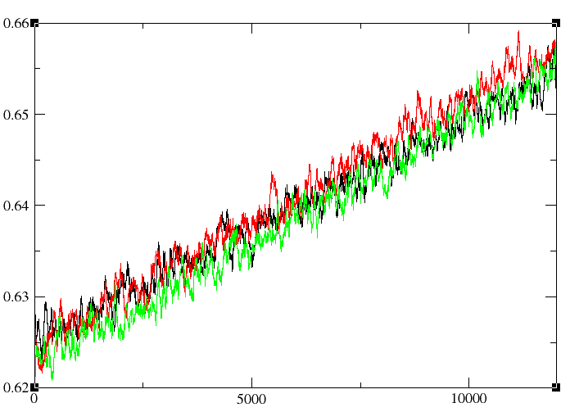Figure 9. 100 year long time series of noise from atmosphere only simulation initialised from teyfa (0.0Ma Scotese). The black line (tfeua) shows the results for the default setup, the red line shows the results if the SST/seaice is smoothed , and the green line is when the GW drag update is applied. This result confirms that the origin of the growth is within the atmosphere and that variability in SST is not important (if anything the smoothed SST has more noise than the original).

As a further test of this setup, I also tried initializing the model from a “normal” preindustrial dump file. This required running the reconfiguration because the Scotese 0.0Ma paleogeogs have a different land sea mask to our normal preind. The results from these simulations are a bit puzzling, but I can hypothesise that the lack of growth maybe down to the simplistic diagnostic (i.e. the noise is still swamped by the strong gradient signal).

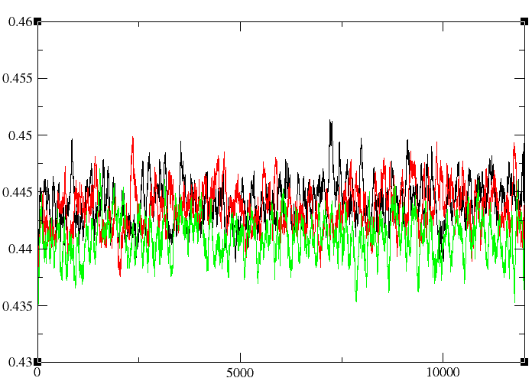

Figure 10. As figure 9 but initialised from a normal preindustrial dump file.

## 

Figure 11 spatial pattern of noise for tfeuf (initialised from normal preind dump file). Should be compared to figure 2. There is more noise from this run than in a standard model so maybe the pattern is growing even though it is not visible in figure 10. Currently lengthening this run to test this idea.

## Removing the noise

A possible brute force approach is to copy the idea from the ocean streamfunction and add additional smoothing. But where? Examination of some other climate fields showed that the U,V and T had no noise. Similarly divergence. There was some in humidity but it was very small. This is what I would hope because the model imposes del6 diffusion which should be effective at removing small scales. However there was a lot of noise with pstar, mslp, and height (and cloud cover/precip etc). I therefore decided to focus on the latter. Moreover, mslp and height (on a constant pressure surface) are diagnosed from pstar which is the prognostic variables.

pstar is calculated from the integral of divergence so I decided to see if I could smooth pstar in the same way of smoothing ocean streamfunction. In a way, this is a more dangerous intervention than with the ocean stream function. Pstar tells us the mass of the atmosphere and can potentially alter the dynamics and create imbalances.

At the end of the subroutine calculating pstar, I added a line:

pstarsmooth(i,j)=pstaroriginal(i,j) + A x 0.25*(pstaroriginal (i+1,j) + pstaroriginal (i-1,j)-2.0*pstaroriginal (i,j))

Again, the only decision was the choice of A. I immediately found that A=1 gave very bad results. After a bit of trial and error I started at:

**A=0.02 (tfeuk) and A=0.01 (tfeum) and A=0.005 (tfeun)**

Appears to generate more problems than it solves. It stops the growth in noise, but the overall noise level is higher than before.

**A=0.001 (tfeuj) and A=0.0005 (tfeuo) and A=0.0001 (tfeup)**

Stops the growth of noise and improves the results compared to the original (tfeue). But does not cure the problem. Noise is still larger than in a normal pre-industrial model.

Conclusion is that the update (with a small value of A does help stop the growth and hopefully prevent the sort of increases seen in the very long transient runs with normal boundary conditions, but it cannot solve the problem caused by the boundary conditions.

## 2. Investigating the Boundary Conditions

The first test was to do some smoothing of the existing orographic files, including smoothing the orography and variances. This did not seem to help much. The smoother orography did reduce the magnitude of the noise but not the growth.